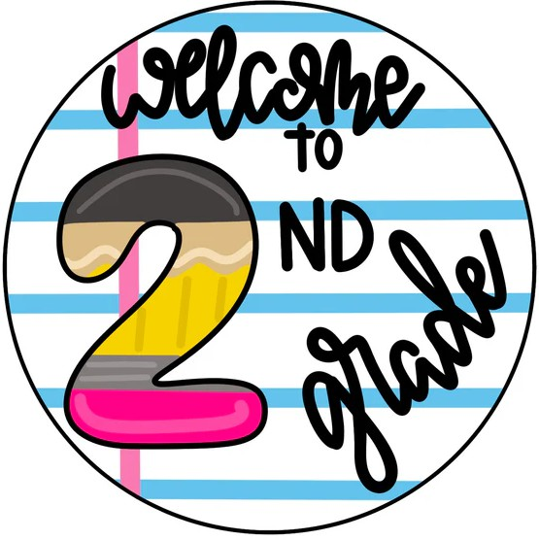
2026-2027 Supply List for Second Grade

Date | Please bring supplies on the dates indicated.  DO NOT BRING ALL SUPPLIES ON ONE DAY!!
Thursday 09/10 | - 2 packs of sharpened yellow, #2 pencils (24 per pack) (Ticonderoga brand preferred)  - 1 pen  - 2 yellow highlighters  - 6 large pink or white erasers  - 4 large glue sticks (Elmers brand preferred)  - 1 box of colored pencils (16 pack of pencils maximum) (Crayola brand preferred)  - 1 box of crayons (24 pack of crayons maximum) (Crayola brand preferred)  - 10 pk. colored markers (Crayola brand preferred)  - 2 packs of post-its 3" x 3" (Post-It Note brand preferred)  - 1 child size scissors (Fiskers or Westcott brand preferred) - label with child's name  - 2 fine point sharpie markers – Black only (NOT ultra-fine)  - 1 hard plastic pencil case – NO LARGER THAN 5” x 8”- 2” high  - 1 pack of skinny low odor Expo markers - Black only (12 pack preferred)  - 4 plastic two-pocket colored folders – label each folder with child’s name & subject  - 1 blue (Math)  - 1 yellow (ELA)  - 1 green (SS./Sci.)  - 1 red (Homework)
Friday 09/11 | - 3 (marble) hard covered notebooks – label with your child’s name  - Homework (HW)  - No label  - No label  - 1 foot long wooden or plastic ruler (non-clear; metric on one side and inches on the other side) – label with child’s name
Monday 09/14 | - 1 ream of copy paper  - 1 pair inexpensive headset/headphones, not earbuds. Please Label with your child’s first and last name and place in a ziploc baggy.
Tuesday 09/15 | - 1 ream of copy paper  - 4 full-size boxes of tissues (for classroom)
Wednesday 09/16 | - 2 boxes of baby wipes (1 for cluster classes and 1 for the classroom)  - 2 rolls of paper towels (1 for the classroom, 1 for the cluster classes- not toilet paper/bathroom roll)
Thursday 09/17 | STUDENTS WITH JANUARY - JUNE BIRTHDAYS:  -Gallon size Ziploc bag - 1 liquid or foam pump hand soap (7oz. or more)  -Construction paper pack (9 x 12 inches) STUDENTS WITH JULY - DECEMBER BIRTHDAYS:  -Quart size Ziploc bags - 1 pump hand sanitizer (7oz. Or more)  -Construction paper pack (12 x 18 inches)
Special Notes | * Please label all supplies with your child’s first and last name  ** A duplicate set of glue sticks, ruler, scissors, pencils, crayons etc. to be kept at home for completion of homework throughout the school year.  *** Teacher’s Wish List  1. Astro brights paper (assorted colors) 2. Laminating Sheets (letter size of 8.9" x 11.4") 3. Lined post-its 3x3  4. Thick colored expo markers 5. Velcro dots or squares 6. Paper clips  7. PaperMate Flair felt tip pens (assorted colors) 8. Electric pencil sharpener

If you have any questions about the supply list, you may contact our Parent Coordinator, Myrna Perez-Fung over the summer at 929-600-5683 or mperez-fung@schools.nyc.gov.

