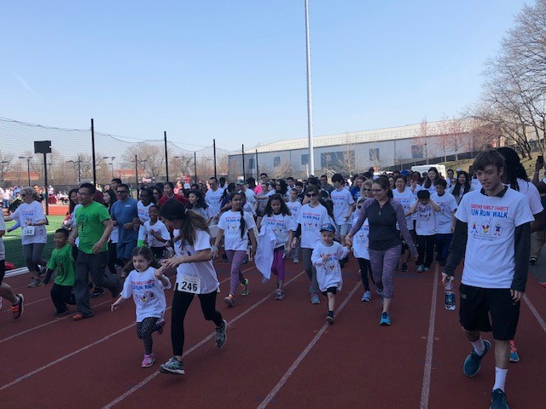
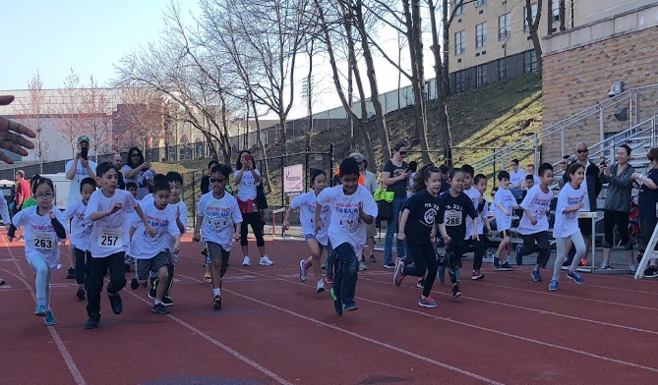
Queens Family Charity Fun Run/Walk
Saturday, May 9, 2020
Register at
http://events.rmh-newyork.org/2020queensfunrun

School/Group Information
To Benefit Ronald McDonald House NY
WHO: Kids and families with kids between the ages of 4-17 and are invited to participate.
WHAT: A fun way to help support Ronald McDonald House.
WHY: On Saturday, May 9, 2020 at 8:45am Families & children ages 4-17 years are invited to participate in the “Ronald McDonald House Family Charity Fun Run & Walk” to benefit Ronald McDonald House New York. This is a great opportunity for kids and families to have fun and raise money for an important cause to support Ronald McDonald House. The mission of Ronald McDonald House is to provide temporary housing to children who have been diagnosed with cancer and their families while the children receive treatment at New York’s renowned medical centers for over 30 years.”
WHERE: St John’s University Track, 8000 Utopia Pkwy, Jamaica NY 11439.
WHEN: Saturday, May 9, 2020 — Official ceremony begins at 8:45 a.m. Warm up with St John’s Running Club
Race Schedule
8:45 am – Opening Ceremony & Warm Ups
9:00 am – 4 & 5 yr-olds, 220 yds. 10:35 am – 10 yr-olds, ½ mile
9:15 am – 6 yr olds, 220 yds. 10:50 Am – 11 yr olds, ½ mile
9:30 am – 7 yr olds, ¼ mile 11:05 pm – 12/13 yr olds, 1/2 mile
9:45 am – 8 yr-olds, ¼ mile 11:20 pm – 14/15/16/17 yr olds, 1 mile
10:00 am – 9 yr olds, ¼ mile
10:15 am – FAMILY WALK, ½ mile
FUN: Volunteers will line the course. All participants will receive a T-shirt and running number when they enter. Upon finishing the race, there will be finishing ribbons & snacks. There will also be fun activity tables before and after each run.
REGISTRATION: Registration Fee is $20 per runner / $40 per family. Online registration will open February 5, 2020 at
http://events.rmh-newyork.org/2019queensfunrun
For information contact Jim Molloy (646) 771-5141 JMolloy@rmh-newyork.org
For Help with your page contact Nicole at NBattista@rmh-newyork.org
*EARLY BIRD SPECIAL* FEE IS ONLY $10 ind / $20 Family IF REGISTERED BY 4/1/2020

Fundraising Prize Levels
(All participants should ask friends and family to sponsor them)

RAISE RECEIVE
$50.00 RMH Towel
$100.00 Fun Run Water Bottle
$250.00 Fun Run Hat Visor
$500.00 Fun Run Sports Pack
$1,000.00 2 Skate With the Greats Tickets
$2,500.00 iPad
Top Boy & Girl Fundraisers receive an Additional Prize

Purpose
To raise Funds for the Ronald McDonald House
New York “Kids Helping Kids”
There are also fantastic prizes for raising money.
Additional Feature
Kid Friendly activities
Need Help
Contact James Molloy at 646 771 5141 or
JMolloy@rmh-newyork.org.

For Help with your page contact Nicole at
NBattista@rmh-newyork.org


In Partnership with St John’s University & the Ozanam Scholars

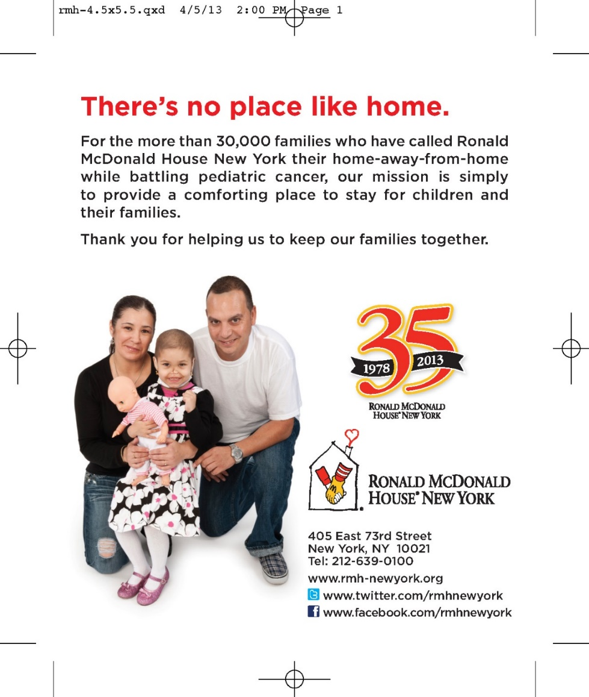


Insert List Here.

