Friendships

Dear Families and Caregivers,

An important dimension of health is the ability to relate well with others. Helping children learn how to make and keep friends helps them build self-esteem and emotional stability. Research shows that children who are able to make and keep friends when they enter school have better attitudes about school, which could contribute to their academic success.

In school, we teach children specific skills that are important for making and keeping friends. You can help by reinforcing these behaviors at home throughout the week:

- Be friendly.
- Play fair and follow the rules.
- Respect others.
- Help others.
- Think about others’ feelings.

Children also learned that making eye contact, using kind words, listening, and paying attention to body language are communication skills that will help them make and keep friends.

Be sure to acknowledge and positively reinforce these behaviors when your child practices them at home. Practicing them at home will help prepare your child to make and keep friends at school.

Help your children set a goal to make and keep friends this week!

Love Always,

The P.S. 188Q Family
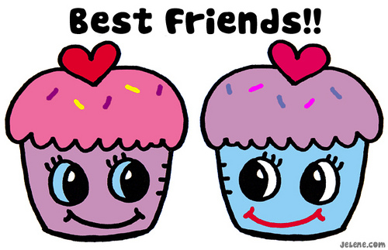

You can find more information at https://www.healthteacher.com/dashboard.

