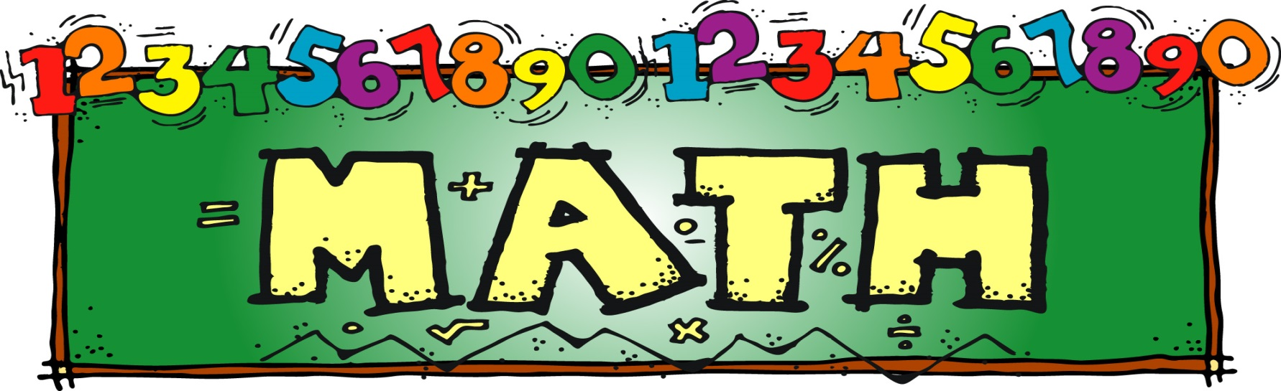

Parent Workshop

Fluency:
Simply Fast and Accurate?
I Think Not!

Date: January 20, 2016
Time: 7:00 p.m. (During the PTA January Meeting)
Location: P.S. 188 Auditorium

I.A., Assistant Principal, Nicole Colon will discuss what it means to be fluent in mathematics. The answer is more than just “fast and accurate.” Building fluency should involve more than speed and accuracy. It must reach beyond procedures and computation.
This workshop is for grades Kindergarten to 5th grade. Looking forward to seeing you there!

