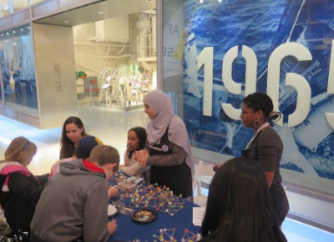

Girls in Science and Engineering Day
Saturday, March 12th, 2016 from 11 AM to 3 PM
Intrepid Sea, Air, and Space Museum
Pier 86 - W. 46th St. between 11th and 12th Ave.
Hangar Deck
Celebrate science, technology, engineering and math at the Intrepid Museum's fourth annual Girls in Science and Engineering Day! Enjoy hands-on experiences, exciting demonstrations and creative discussions offered by various science-based organizations, clubs and college.
RSVP before March 9th deadline for free admission.

Division of Family and Community Engagement

