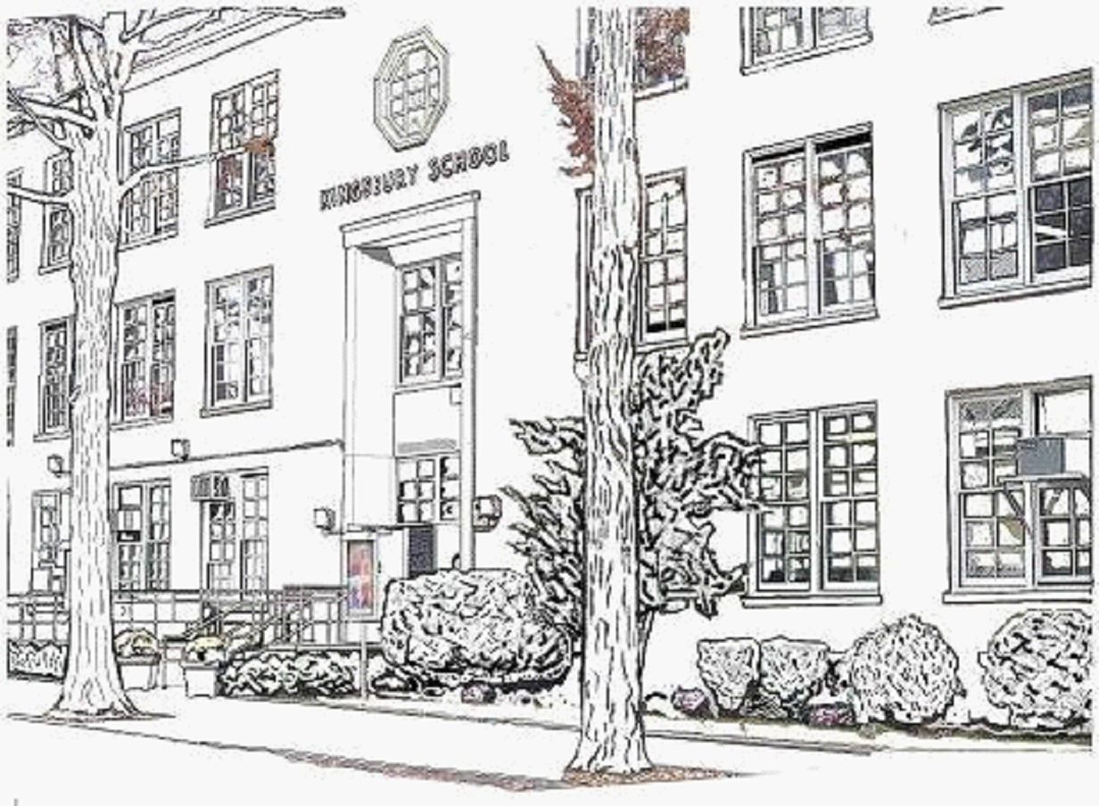Kingsbury School – P.S. 188Q/ANNEX
218-12 Hartland Avenue, Bayside, New York 11364
Tel: (718) 464-5768 Fax: 718-464-5771
Janet Caraisco, Ed. D., Principal Nicole Colon, Assistant Principal, I.A.

P.T.A. of P.S.188Q/ANNEX

Notice of January PTA Meeting & Agenda

Date: Wednesday, January 20, 2016
Time: 6:30 PM Executive Board
Time: 7:00 PM General Membership

Place: Auditorium - Main Building

Hospitality: Light Refreshments

Agenda: 1. Reading & Approval of Minutes

2. Reading & Approval of Treasurer’s Report

3. PTA Presidents’ Report / Old & New Business

Lunar New Year Committee Update
Read-A-Thon Poster Contest Winners
Read-Aloud
Read-A-Thon 1/19-1/28
Presentation of Proposed PTA Bylaws

4. Principal’s Report

5. Parent Coordinator’s Report

6. School Leadership Team Report

7. Math Fluency Workshop K-5 (presented by Ms. Colon)

8. Adjournment

We look forward to seeing you.

Sincerely,
Anne Tien & Tracy Stefandl
PTA Co-Presidents 2015-2016
E-mail: pta@ps188q.org

Next Meeting: Wednesday, February 24, 2016 @ 9:00 AM

