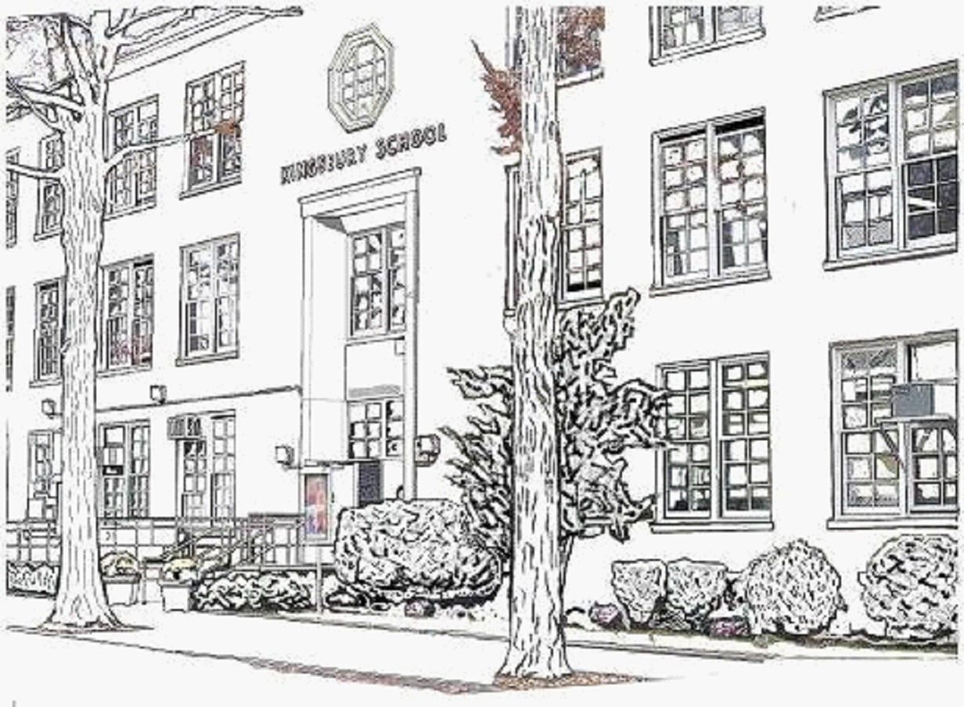Kingsbury School – P.S. 188Q/ANNEX
218-12 Hartland Avenue, Bayside, New York 11364
Tel: (718) 464-5768 Fax: 718-464-5771
Janet Caraisco, Ed. D., Principal Nicole Colon, I.A., Assistant Principal

P.T.A. of P.S.188Q/ANNEX

Notice of December PTA Meeting & Agenda

Date: Wednesday, December 16, 2015
Time: 8:30 AM Executive Board
Time: 9:00 AM General Membership

Place: School Cafeteria- Main Building

Hospitality: Light Refreshments

Agenda: 1. Reading & Approval of Minutes

2. Reading & Approval of Treasurer’s Report

3. PTA Presidents’ Report / Old & New Business
Student Council Fundraising Presentation
Modell’s Holiday Coupon Event Nov.20th -Dec.17th
Lunar New Year Committee Feb. 5th
Photo Retake
Read-a-thon Poster Contest
Read-Aloud

4. Principal’s Report

5. Parent Coordinator’s Report

6. School Leadership Team Report

7. Adjournment

We look forward to seeing you.

Sincerely,
Anne Tien & Tracy Stefandl
PTA Co-Presidents 2015-2016
E-mail: pta@ps188q.org

Next Meeting: Wednesday, January 20, 2016 @ 7:00 PM

